**Question 1 :**  
*Which customer acquisition channels are most effective? Analyze acquisition trends over time and measure activation rates and initial order values.*

**Steps to Solve:**

1. **Create Acquisition Columns:**
   * Add an AcquisitionMonth column from DateEntered (format: yyyy-MM).
   * Add an AcquisitionQuarter column by combining year and quarter (e.g., 2025-Q1).
2. **Analyze Acquisition Trends:**
   * Group customers by AcquisitionQuarter and AcquisitionMonth.
   * Count new customers (NewCustomers).
3. **Measure Performance After Acquisition:**
   * Join customer and order data.
   * Group by AcquisitionMonth to calculate:
     + Average initial order value (AvgInitialOrderValue).
     + Number of active customers (ActiveCustomers).
4. **Calculate Activation Rate:**
   * Find activation rate as (ActiveCustomers / NewCustomers) × 100.
5. **Select and Display Results:**
   * Show acquisition quarter, month, new customers, active customers, activation rate, and average initial order value.

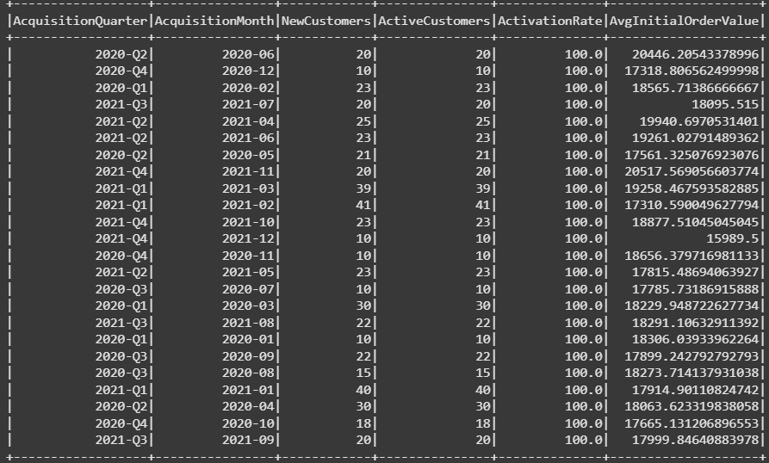

**Question:**  
*Which regions (country/state) generate the highest sales revenue along with the number of orders?*

**Steps to Solve:**

1. **Join Orders with Customers** using CustomerID.
2. **Group data by** Country and State.
3. **Aggregate metrics:**
   * Sum Total_Order_Amount as TotalRevenue.
   * Count OrderID as NumberOfOrders.
4. **Order results** by TotalRevenue in descending order.
5. **Display the top 10 regions**.

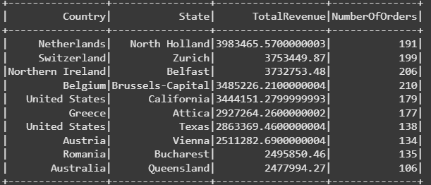

**Question:**  
*Analyze supplier performance by calculating average delivery time, order count, and average order value.*

**Steps to Solve:**

1. **Join multiple tables:**  
   Join Orders, OrderDetails, Products, Category, and Suppliers on appropriate IDs.
2. **Calculate Delivery Time:**  
   Add a new column OrderToDeliveryDays as the difference between DeliveryDate and OrderDate.
3. **Group by Supplier and Category:**  
   Group the data by SupplierID, CompanyName, and CategoryName.
4. **Aggregate Metrics:**
   * Average delivery time (AvgDeliveryDays).
   * Total number of orders (OrderCount).
   * Average order value (AvgOrderValue).
5. **Order Results:**  
   Sort the results by AvgDeliveryDays in descending order.

